**Hill Lane Surgery**

**Newsletter**

**OCTOBER 2018**

**Hello and welcome to our second newsletter. I hope you all enjoyed the lovely weather we had in the summer, and in fact are continuing to have!!! With winter fast approaching we are now offering flu vaccinations at the surgery. If you haven’t already done so, please call the surgery to book your appointment, or to let us know if you do not wish to have one.**

**We really do value feedback from our patients and so I will shortly be emailing you all a survey. This is not just a tick box exercise, as it is important for us to know what we are doing well and what we need to improve on. I would be very grateful if you could take the time to feedback to us with any suggestions.**

**Kind Regards**

**Paula**

**Practice Manager**

**Hill Lane Surgery**

**Flu Vaccinations**

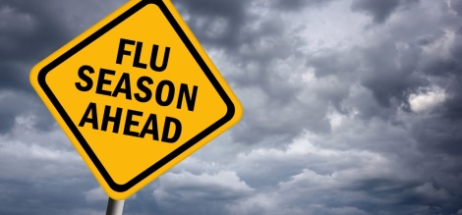

**Click on the links below for more information:**

**Flu Vaccination: who should have it this winter and why**

**Flu Vaccination Information 2018**

**[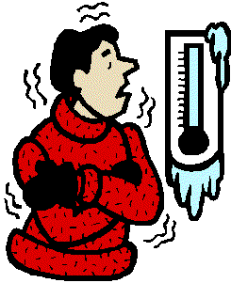](http://www.cliparthut.com/cold-weather-clip-art-clipart-9AMocS.html)Keep Warm, Keep Well**

Cold homes can have a big impact on your health, and one of the most effective ways of keeping well during winter is to stay warm. This can help prevent colds and flu, as well as more serious conditions, including pneumonia, heart attacks, strokes and depression.

**Try some of these tips to help keep you warm this winter:**

* Draw your curtains at dusk and keep doors closed to block out draughts.
* Have hot drinks regularly, and eat at least one hot meal a day if you can. By eating regularly you can keep energy levels up during winter.
* Instead of wearing one chunky layer of clothing, wear several light layers of warm clothes.
* Keep active in your home if possible, movement will help keep you warm. Wear shoes with a good grip if you need to go outside on cold days.
* Keep your bedroom at 18°C and main living room at 21°C (65 and 70°F). If you can’t heat all the rooms you use, heat the living room during the day and the bedroom just before you go to sleep.
* Try to go and see friends, relatives or neighbours who may be vulnerable to cold weather. Cold weather is especially dangerous for older people or people with serious illnesses, so check up on them if you can.

**For more information on keeping warm and well, visit the following NHS website**

**https://www.nhs.uk/live-well/healthy-body/keep-warm-keep-well/**

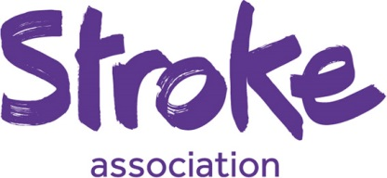

**What is a Stroke?**

A stroke is a brain attack. It happens when the blood supply to part of your brain is cut off. Blood carries essential nutrients and oxygen to your brain. Without blood your brain cells can be damaged or die.

This damage can have different effects, depending on where it happens in your brain.

A stroke can affect the way your body works as well as how you think, feel and communicate.

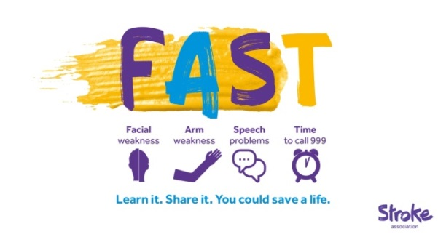**What is a mini-stroke?**

A transient ischaemic attack (TIA) is also known as a mini-stroke. It is the same as a stroke, except that the symptoms last for a short amount of time and no longer than 24 hours. Although the symptoms may not last long, a TIA is still very serious. It is a sign that there is a problem and you are at risk of having a full-blown stroke.

**What can I do to reduce my risk of stroke?**

**Manage your medical conditions** – have regular check-ups with your GP, to check for high blood pressure, diabetes, high cholesterol and atrial fibrillation (all of these conditions increase your risk of stroke). If you have one (or more) of these conditions, make sure you take the medication you’re prescribed.

**Stop smoking** - you are twice as likely to die from stroke if you smoke. So stopping smoking is one of the most important things you can do to reduce your risk of stroke.

**Drink less alcohol** - Drinking too much alcohol raises your blood pressure. If your blood pressure is too high, it puts a strain on your arteries and heart, which can lead to a stroke. Binge drinking is particularly dangerous as it can cause your blood pressure to rise very quickly.

**Stay a healthy weight** - being overweight puts you at risk of high blood pressure, heart disease and type 2 diabetes, all of which increase your risk of a stroke.

**Do more exercise** - regular exercise can help to lower your blood pressure and help you maintain a healthy weight. Research shows that regular moderate exercise can reduce your risk of stroke by 27%

**Eat a healthy diet** - Eating a healthy, balanced diet can help to lower your blood pressure and control diabetes. Eating well can also reduce your cholesterol level.

*The Stroke Association are the UK’s leading charity dedicated to conquering strokes. For more information visit: www.stroke.org.uk*

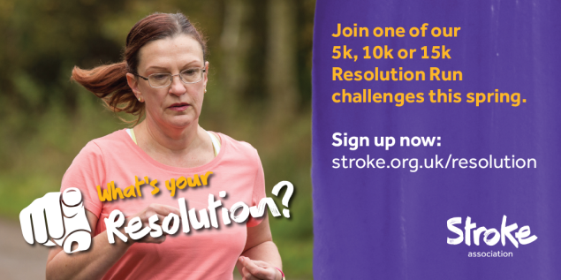

**Podiatry Drop In Service**

**Please see some information on the next page, regarding the services that are offered locally at the Adelaide Centre and at Bitterne Health Centre.**

